Tutorial 11 (Additional)
1.
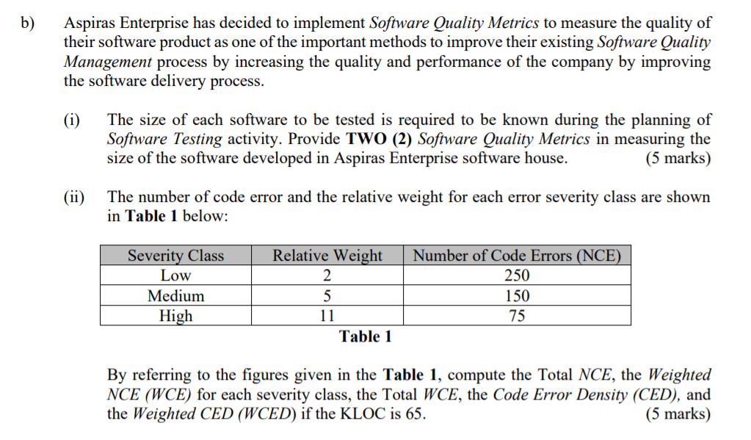

2. Calculate the Development Errors Removal Effectiveness (DERE) if the total number of development errors is 65 and Total Number of Failure Detected in a software of a year is 300.

3. The following table shows the development milestone of a software.
Milestone | Hours of working
M1 | 240
M2 | 360
M3 | 160
M4 | 200
M5 | 60

Assumed that the program size is 250 KLOC, and 20% of the codes are reused from previous project. The new project has produced 580 pages of documents and 120 pages are reused from previous project. Calculate DevP, Cre, DocRe.

4. An online system is expected to operate 24 hours a year (365 days). However, the total time of the system that is not able to provide some services is 144 hours. From the 144 hours, 20 hours of total time where the system is not able to perform important e-commerce activities. In addition, a total of 15 hours that the system is totally failed.

Calculate Full Availability, Vital Availability and Total Unavailability of the system.

